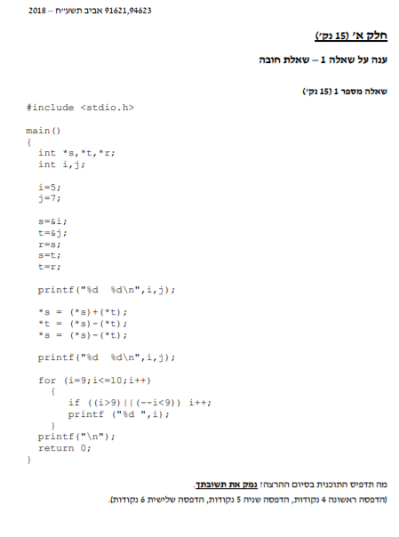

int main()

{

int *s, *t, *r;

int i, j;

i = 5;

j = 7;

s = &i;//s gets the address of i

t = &j;//t gets the address of j

r = s;//r gets the address of i

s = t;//s gets the address of j

t = r;//t gets the address of i

printf("%d %d\n", i, j);//prints i and j (5 7)

*s = (*s) + (*t);//changes j to the sum of j+i(12)

*t = (*s) - (*t);//changes i to the sub of j-i(7)

*s = (*s) - (*t);//changes j to the sub of j-i(5)

printf("%d %d\n", i, j);//prints i and j(7 5)

for (i = 9; i <= 10; i++)

{

if ((i>9)||(--i<9)) i++;//1st round enters with i=8,2nd round enters with i=10

printf("%d ", i);//1st round print i(9), 2nd round print i(11)

}

printf("\n");

return 0;

}

|  |  |  |  |  |  |
| --- | --- | --- | --- | --- | --- |
| s | t | r | i | j | print |
|  |  |  | 5 |  |  |
|  |  |  |  | 7 |  |
| &i |  |  |  |  |  |
|  | &j |  |  |  |  |
|  |  | s |  |  |  |
| t |  |  |  |  |  |
|  | r |  |  |  |  |
|  |  |  |  |  | 5 7 |
|  |  |  |  | 12 |  |
|  |  |  | 7 |  |  |
|  |  |  |  | 5 |  |
|  |  |  |  |  | 7 5 |
|  |  |  | 9 |  |  |
|  |  |  | 8 |  |  |
|  |  |  | 9 |  |  |
|  |  |  |  |  | 9 |
|  |  |  | 10 |  |  |
|  |  |  | 11 |  |  |
|  |  |  |  |  | 11 |

Final print

5 7

7 5

9 11